Thermal Design

Every component inside the system should be considered as a heat source. Therefore, to prevent component which were used in the system, thermal design was done for the system. In our system, especially, thermal design was done for the three phase diode rectifier and the switching element which is MOSFET. Since, they produce more heat than other element and the temperature is critical for them. To prevent MOSFET from the increasing heat problem heatsink and fan were used.

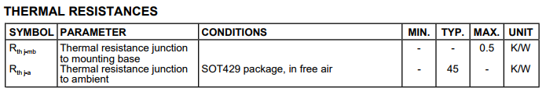

Figure 1: Thermal Characteristic of the MOSFET (model: IRFP460)

Thermal characteristic of the heatsink were calculated according to maximum current and voltage levels. Expected maximum current flow through MOSFET is equal to 12A under full-load condition. And also calculations are considered at full conduction period.

$$I_{max}=12A$$

$$V_{DS}=0.27Ω*I_{max}=3.24V$$

$$P_{C}=I_{max}*V_{DS}= 38.88W$$

$$T_{change}=P_{C}*\left(R_{th j-mb}+R_{th j-a}\right)=1769.04C^{0}$$

According to calculations, while system working under full-load, temperature of the MOSFET will increased 1769.04degree from the room temperature and it will burn suddenly.

We decided that under full load, maximum temperature of the MOSFET should remain at most 80degree. So that heat capacity of the heatsink should be equal to,

$$R_{heatsink}=\frac{80-25}{12*3.24}=1.41\frac{K}{W}$$

Then, we searched a heat sing that provide this characteristic.

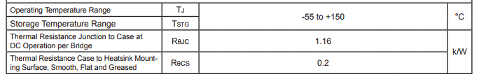

Figure 2: Thermal Characteristic of the Diode Rectifier (model: SBR3516)

Same procedure applied for the calculation of the diode rectifier heatsink. Maximum current flow through on diode rectifier is nearly equal to 5.3A at full-load.

$$I_{max}=5.3A$$

According to datasheet of the diode rectifier, maximum voltage drops per element at 12.5A/17.5A peak is equal to 1.2V. At the same time, two of the element will be open so that, voltage drop will equal to 2.4V.

$$V_{drop}=2.4V$$

$$P_{C}=I_{max}*V_{DS}= 12.72W$$

$$T_{change}=P_{C}*\left(R_{th j-mb}+R_{th j-a}\right)=17.3C^{0}$$

According to calculations, we do not need any heatsink for the diode rectifier but stay in safe region we bought a heatsink for the three phase diode rectifier.